**Lab Exercise 3**

**AIM: Encapsulation and Inheritance**

**1. Encapsulation:**

class Scs{

public String name(){

return name; }

private int age;

private int sal;

public int getage(){

return age;

}

public int getsal(){

return sal;

}

public void setage(int newage){

age = newage;

}

public void setsal(int newsal){

sal = newsal;

}

}

class D1 extends Scs{

public void FacD1(){

Scs obj1 = new Scs();

obj1.name("Shraddha");

obj1.setage(35);

obj1.setsal(100000);

System.out.println("Department: D1 Name: " + obj1.name() + "Age: " + obj1.getage() + "sal: " + obj1.getsal());

}

}

class D2 extends D1{

public void FacD2(){

Scs obj2 = new Scs();

obj2.name("Saksham");

obj2.setage(34);

obj2.setsal(200000);

System.out.println("Department: D2 Name: " + obj2.name() + "Age: " + obj2.getage() + "sal: " + obj2.getsal());

}

}

class D3 extends D2{

public void FacD3(){

Scs obj3 = new Scs();

obj3.name("Sunita");

obj3.setage(45);

obj3.setsal(300000);

System.out.println("Department: D3 Name: " + obj3.name() + "Age: " + obj3.getage() + "sal: " + obj3.getsal());

}

}

class D4 extends D3{

public void FacD4(){

Scs obj4 = new Scs();

obj4.name("Dhruv");

obj4.setage(36);

obj4.setsal(400000);

System.out.println("Department: D4 Name: " + obj4.name() + "Age: " + obj4.getage() + "sal: " + obj4.getsal());

}

}

public class Admin{

public static void main(String args[]){

D4 obj = new D4();

obj.FacD1();

obj.FacD2();

obj.FacD3();

obj.FacD4();

}

}

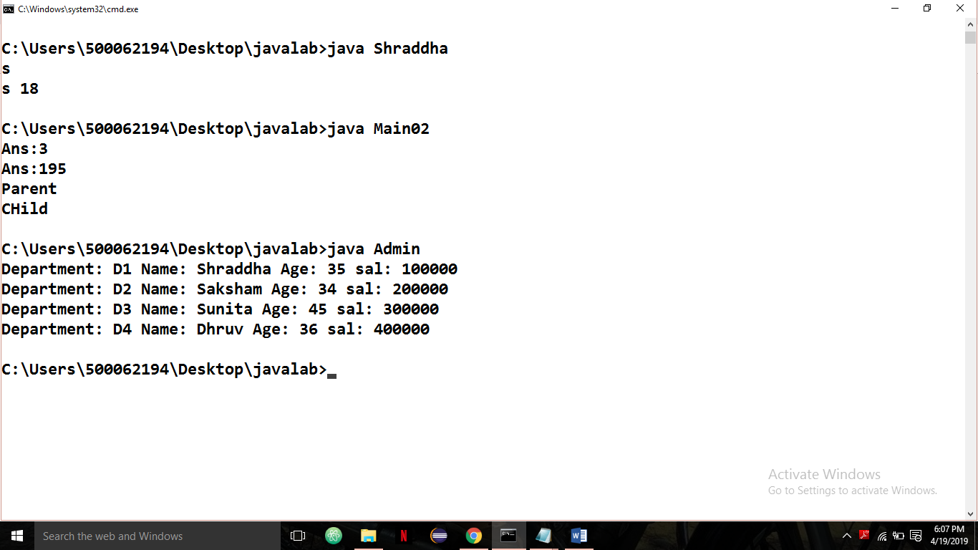

**2. Inheritance**

class Tea{

public Tea()

{

System.out.println("Class Tea");

}

public void type(int a)

{

System.out.println("the type of drink rates:" +a);

}

}

class Green extends Tea{

public Green()

{

System.out.println("Class Green");

}

public void type(String s)

{

System.out.println("type: " +s);

}

public void taste()

{

System.out.println("bitter");

}

}

public class Lemon extends Green{

public Lemon()

{

System.out.println("Lemon");

}

public void taste()

{

System.out.println("citrus");

}

public static void main(String args[])

{

Lemon obj=new Lemon();

obj.type(10);

obj.type("Green");

obj.taste();

Green obj2=new Green();

obj2.taste();

}

}

